Batch: A2 Roll No.: 16010122034

Experiment No. 5

Grade: AA / AB / BB / BC / CC / CD /DD

Signature of the Staff In-charge with date

Title: Implementation of Basic operations on queue for the assigned application using Array and Linked List- Create, Insert, Delete, Destroy

Objective: To implement Basic Operations on Queue i.e. Create, Push, Pop, Destroy for the given application

Expected Outcome of Experiment:

CO | Outcome
1 | Explain the different data structures used in problem solving

Books/ Journals/ Websites referred:
- Fundamentals Of Data Structures In C – Ellis Horowitz, Satraj Sahni, Susan Anderson-Fred
- An Introduction to data structures with applications – Jean Paul Tremblay,
Paul G. Sorenson
- Data Structures A Pseudo Approach with C – Richard F. Gilberg & Behrouz A. Forouzan

Abstract:
(Define Queue, enlist queue operations).

•Definition:
- An ordered collection of homogenous data items
- Where elements are added at rear and removed from the front end
•Operations:
- Create an empty queue
- check if it is empty and/or full
- Enqueue: add an element at the rear
- Dequeue: remove the element in front
- Destroy: remove all the elements one by one and destroy the data structure

List 5 Real Life applications of Queue:
Queues are data structures that follow the First-In-First-Out (FIFO) order, making them suitable for various real-life applications where tasks or data must be processed in a specific order. Here are five real-life applications of queues:
1. Print Job Management: In a computer system with multiple users, print jobs are often sent to a shared printer. These print jobs are typically processed in the order they are received, forming a queue. Users submit their print jobs, and the printer processes them one by one in a first-come, first-served manner.
2. Call Center Systems: Call centers use queues to manage incoming customer service calls. Calls are placed in a queue and assigned to available customer service representatives based on the order they were received. This ensures that calls are handled in the order they are received, maintaining fairness and efficiency.
3. Breadth-First Search (BFS) Algorithm: BFS is an essential graph traversal algorithm used in various applications such as network routing and web crawling. It explores nodes level by level, ensuring that all nodes at a particular level are processed before moving to the next level. A queue is used to keep track of nodes at each level.
4. Task Scheduling in Operating Systems: Operating systems often use queues to manage processes or tasks. The ready queue holds processes waiting to be executed by the CPU. The operating system scheduler selects the next process to run based on the scheduling algorithm, such as Round Robin, which uses a queue-like structure.
5. Traffic Management: Traffic signal control systems at intersections use queues to manage vehicle traffic. Each lane of traffic forms a queue, and the traffic signal controller determines which queue to give the green light based on various factors like traffic density and waiting time.

Define and explain various types of queue with suitable diagram and their application(s):
1. Circular Queue: Circular Queue is a linear data structure in which the operations are performed based on FIFO (First In First Out) principle and the last position is connected back to the first position to make a circle. It is also called ‘Ring Buffer’. This queue is primarily used in the following cases:
- Memory Management: The unused memory locations in the case of ordinary queues can be utilized in circular queues.
- Traffic system: In a computer-controlled traffic system, circular queues are used to switch on the traffic lights one by one repeatedly as per the time set.
- CPU Scheduling: Operating systems often maintain a queue of processes that are ready to execute or that are waiting for a particular event to occur.
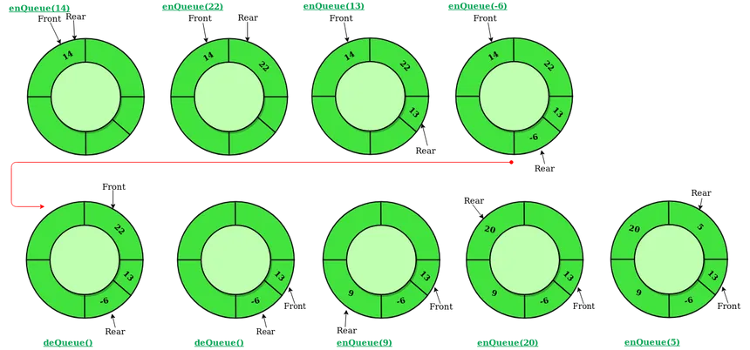

2. Input restricted Queue: In this type of Queue, the input can be taken from one side only(rear) and deletion of elements can be done from both sides(front and rear). This kind of Queue does not follow FIFO(first in first out). This queue is used in cases where the consumption of the data needs to be in FIFO order but if there is a need to remove the recently inserted data for some reason and one such case can be irrelevant data, performance issue, etc.
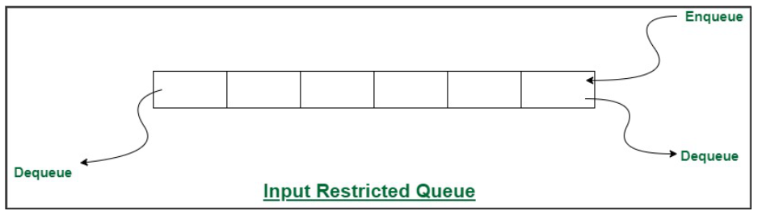

3. Output restricted Queue: In this type of Queue, the input can be taken from both sides(rear and front) and the deletion of the element can be done from only one side(front). This queue is used in the case where the inputs have some priority order to be executed and the input can be placed even in the first place so that it is executed first.

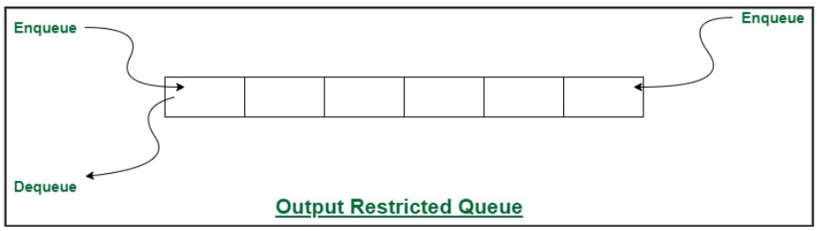

4. Double ended Queue: Double Ended Queue is also a Queue data structure in which the insertion and deletion operations are performed at both the ends (front and rear). That means, we can insert at both front and rear positions and can delete from both front and rear positions. Since Deque supports both stack and queue operations, it can be used as both. The Deque data structure supports clockwise and anticlockwise rotations in O(1) time which can be useful in certain applications. Also, the problems where elements need to be removed and or added both ends can be efficiently solved using Deque.
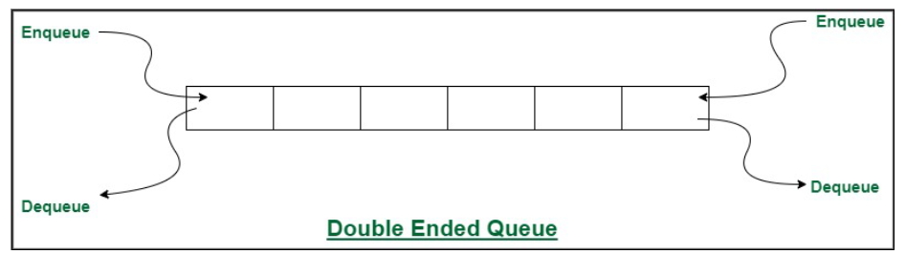
5. Priority Queue: A priority queue is a special type of queue in which each element is associated with a priority and is served according to its priority. There are two types of Priority Queues. They are:
- Ascending Priority Queue: Element can be inserted arbitrarily but only smallest element can be removed. For example, suppose there is an array having elements 4, 2, 8 in the same order. So, while inserting the elements, the insertion will be in the same sequence but while deleting, the order will be 2, 4, 8.
- Descending priority Queue: Element can be inserted arbitrarily but only the largest element can be removed first from the given Queue. For example, suppose there is an array having elements 4, 2, 8 in the same order. So, while inserting the elements, the insertion will be in the same sequence but while deleting, the order will be 8, 4, 2.
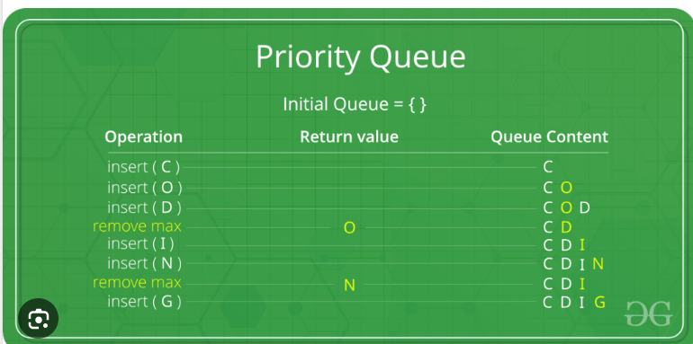

Queue ADT:

The Queue ADT: Value definition
Abstract typedef QueueType(ElementType ele)
Condition: none

Queue ADT: Operator definition
1. Abstract QueueType CreateQueue()
Precondition: none
Postcondition: Empty Queue is created

2. Abstract QueueType Enqueue(QueueType Queue, ElementType Element)
Precondition: Queue not full or NotFull(Queue)= True
Postcondition: Queue = Queue‟ + Element at the rear
Or Queue = original queue with new Element at the rear
3. Abstract ElementType dequeue(QueueType Queue) Precondition: Queue not empty or NotEmpty(Queue)= True Postcondition: Dequeue= element at the front Queue= Queue - Element at the front Or Queue = original queue with front element deleted
4. Abstract DestroyQueue(QueueType Queue)
Precondition: Queue not empty or NotEmpty(Queue)= True
Postcondition: Element from the Queue are removed one by one starting from front to rear.
NotEmpty(Queue)= False
5. Abstract Boolean NotFull(QueueType Queue)
Precondition: none
Postcondition: NotFull(Queue)= true if Queue is not full
NotFull(Queue)= False if Queue is full.

6. Abstract Boolean NotEmpty(QueueType Queue)
Precondition: none
Postcondition: NotEmpty(Queue)= true if queue is not empty
NotEmpty(Queue)= False if Queue is empty.

Algorithm for Queue operations using array/Linked list : (Write only the algorithm for assigned type)

enqueue()
- Start
- Create new node newNode
- Set newNode->data = added_item
- Set newNode->next = NULL
- Check if head has lower priority. If true follow go to step 6. Else go to Step 8.
- Set newNode->next = front
- Set front = newNode. Go to step 10.
- Set temp = front
- While temp->next != NULL and temp->next->priority -> priority Set temp = temp->next.
- Set newNode->next = temp->next
- Set temp->next = newNode
- End

dequeue()
- Start
- If front == null, then print “underflow” and go to step 6
- Set Temp = front
- Set front = front->next
- Free temp
- End
Implementation Details:
- Mention the application assigned to you and explain how you implemented the solution using the assigned type of Queue.

CIRCULAR QUEUE USING ARRAY:
A simple algorithm provided to explain the procedure followed:
1. deQueue(): Dequeues first element
2. enQueue(): Enqueues element at the rear of the queue
2. isEmpty(): Checks if the deque is empty by verifying if front is -1.
3. isFull(): Checks if the deque is full by examining whether it is circularly full or not.
4. display(struct Deque dq): Displays the elements of the deque starting from the front and iterating through the circular buffer until it reaches the rear.
5. main(): The main function provides a menu-driven interface for the user to interact with the Queue.

https://www.programiz.com/dsa/circular-queue
Program source code:
// Circular Queue implementation in C

#include <stdio.h>

#define SIZE 5

int items[SIZE];
int front = -1, rear = -1;

// Check if the queue is full
int isFull() {
if ((front == rear + 1) || (front == 0 && rear == SIZE - 1)) return 1;
return 0;
}

// Check if the queue is empty
int isEmpty() {
if (front == -1) return 1;
return 0;
}

// Adding an element
void enQueue(int element) {
if (isFull())
printf("\n Queue is full!! \n");
else {
if (front == -1) front = 0;
rear = (rear + 1) % SIZE;
items[rear] = element;
printf("\n Inserted -> %d", element);
}
}

// Removing an element
int deQueue() {
int element;
if (isEmpty()) {
printf("\n Queue is empty !! \n");
return (-1);
} else {
element = items[front];
if (front == rear) {
front = -1;
rear = -1;
}
// Q has only one element, so we reset the
// queue after dequeing it. ?
else {
front = (front + 1) % SIZE;
}
printf("\n Deleted element -> %d \n", element);
return (element);
}
}

// Display the queue
void display() {
int i;
if (isEmpty())
printf(" \n Empty Queue\n");
else {
printf("\n Front -> %d ", front);
printf("\n Items -> ");
for (i = front; i != rear; i = (i + 1) % SIZE) {
printf("%d ", items[i]);
}
printf("%d ", items[i]);
printf("\n Rear -> %d \n", rear);
}
}

int main() {
// Fails because front = -1
deQueue();

enQueue(1);
enQueue(2);
enQueue(3);
enQueue(4);
enQueue(5);

// Fails to enqueue because front == 0 && rear == SIZE - 1
enQueue(6);

display();
deQueue();

display();

enQueue(7);
display();

// Fails to enqueue because front == rear + 1
enQueue(8);

return 0;
}

Output Screenshots:
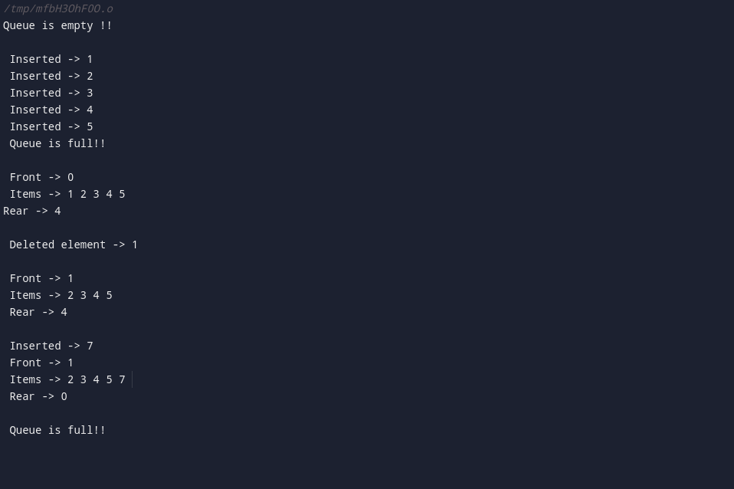

Applications of Queue in computer science:
- Task Scheduling: Queues are used in operating systems to manage and schedule tasks or processes for execution based on their priority and arrival time.
- Data Buffering: Queues are employed to buffer data between components or processes to ensure efficient and synchronized communication, such as in networking and I/O operations.
- Breadth-First Search (BFS): BFS algorithms use queues to explore and traverse graphs level by level, making them valuable in graph algorithms and network routing.
- Print Job Management: In computer networks and systems with shared printers, queues are used to manage and process print jobs in the order they are received.
- Task Queues: Queues are used in task distribution systems, such as job scheduling, message queuing systems, and distributed computing environments, to manage and distribute tasks among multiple workers or processes.
- Web Crawler: In web crawling and scraping, a queue is employed to manage URLs and prioritize which pages to visit next, ensuring comprehensive coverage of a website or the internet.

Conclusion:-
Hence, various operations on the assigned queue type: doubly ended queue were learnt and performed accordingly.

